**Why Is Solar Energy Being Embraced by Businesses?**

Commercial utilization of energy takes a sizeable chunk out of a country’s energy quota. In the United States alone, [40% of](https://www.renewableenergyworld.com/ugc/articles/2018/02/27/embracing-renewables-on-the-energy-management-journey.html) the energy that’s produced is utilized by businesses. So it’s no wonder that a considerable amount of attention is being given to techniques that save energy.

Studies show that the commercial adoption of solar power systems is the latest trend. Walmart boasts an impressive 142 MW of solar photovoltaic (PV) capacity across 348 installations. Other retailers such as Target, Apple, Costco, Kohl’s, IKEA, Macy’s, Walgreens, etc. are also on the list of top American companies that are using solar power. However, it is not restricted only to the US. All over the world, various organizations are incorporating this technology.

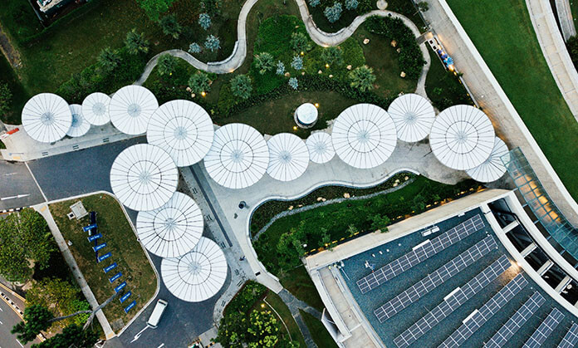

Why are many businesses moving towards solar energy?

“Going green” and “reducing the carbon footprint” are valid reasons for adopting solar power systems. But they are no longer goals, only for organizations, who aim at reversing global warming or saving the planet. More companies are now embracing the transition to renewable forms of energy than ever before.

What’s the reason behind this change?

1. Cutting fuel dependency

For many, it is a way to remain profitable by reducing overhead costs. As non-renewable resources such as coal and oil are limited in supply, the price of traditional power is likely to keep rising. On the other hand, there has been substantial growth in the solar sector over the last decade. The average price of a solar panel has dropped by [more than 60%](https://news.energysage.com/solar-panel-efficiency-cost-over-time/). Leveraging renewable sources of energy has the benefit of increasing sustainability to the business. Wavering fuel costs will no longer influence it.

2. Long-term planning

Even with a high cost of installation, companies are still opting this route. Organizations can tap into the full potential of solar power by employing the services of professional and experienced solar installation companies. They possess the right technology and skills required to position, install, and maintain optimal performance. Most importantly, they utilize solar automation software such as [Scoop Solar](https://www.scoop.solar/) to keep data between the office and field up to date.

There are creative options available for businesses depending on where they wish to install the system on their premises, such as on rooftop installations, ground-mounted arrays, and parking lot canopy solutions. Many select a combination of arrays to meet their requirements for operating retail stores, office buildings, corporate campuses, manufacturing facilities, data centers, or warehouses. The type of building and the activities the company plans dictates the type of installation.

3. Great ROI

All businesses are familiar with making long-term investments, especially those with high ROIs. So this is not a new concept. The cost of installation, though a bit pricey, has decreased considerably over the years. Since the price varies from place to place, organizations have the option to select an installation site depending upon general incentives that they can avail in that area.

Even so, businesses are willing to foot the bill for long-term gains. Most have experienced a 40 to 70 percent decrease in their electric bill. The life of a well-maintained solar power system is about 25–30 years. The average time to pay off the investment is 6 to 9 years; after which business owners can technically avail free electricity after this period.



4. Various options

The renewable energy industry is providing numerous options, and over the coming years, the technology is bound to advance even more. Businesses are already receiving tax credits in some places for implementing “green” tech.

But besides this, as solar power systems are becoming more common, panels can now be either bought in cash, financed through a loan, or leased under a contract.

5. Systems are much cheaper

The costs of both manufacturing and installing photovoltaic solar panels has dramatically decreased. Installation costs have currently dropped to [more than 70%](https://www.seia.org/solar-industry-research-data) over the last decade. This alone is a huge incentive for many to implement a PV system. But tax incentives have also made it an attractive option. In some countries, federal policies such as a solar Investment Tax Credit (ITC) have supported the growth of the solar industry.

6. A way to reduce utility bills

Let’s not forget that net-metering policies are providing opportunities for businesses to make money by feeding excess electricity to the grid. Though there is very little chance that the organization will receive hard cash for generating excess power, it can be used to build a credit with the utility company. When the PV system cannot provide sufficient power for the business, this credit can be utilized to pay for the deficit.

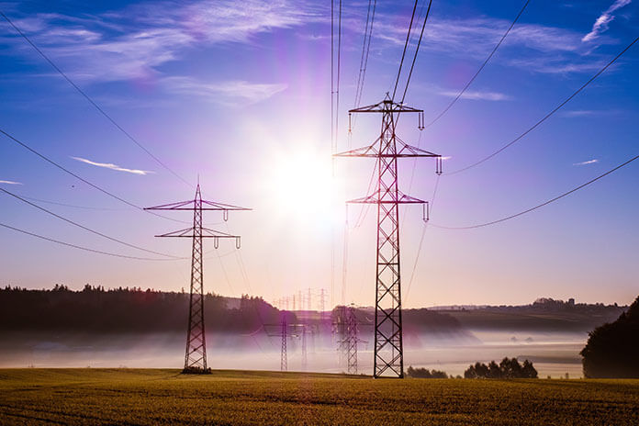

Buy, loan, or lease a solar power system?

For businesses that wish to maximize their financial benefits, installing a personal PV system is the best option. They can save money through federal tax incentives or cash rebates. However, they will be responsible for the maintenance and care of the system.

A way to bypass this is through a solar lease. Even though companies won’t receive any tax credits, they don’t have to put any cash down or worry about maintenance. It’s a hassle-free option for organizations to avail cheaper electricity instantly. Many leasing companies provide apps so that entrepreneurs can monitor the efficiency of their PV system. However, the agreement is typically a long-term one, 20–25 years, after which the lease can be renewed, or the system can be purchased.

Loans, on the other hand, are generally offered for 10–20-year terms with an interest rate between 3 to 8%. But even before a business owner decides to install a system, various factors influence the cost of installing a solar power system, such as:

The energy requirement of the business

The more the requirement, the bigger the size of the system and the greater the number of panels that will need to be installed. This correlates directly with the total cost of the PV system.

The type of system that a company selects

Not all solar panels are created equal. There is a variety of material and quality that determine the cost of each panel.

The location where panels are to be installed

Some rooftops are steep and difficult to work on. So generally, roofs require more time and effort during installation as compared to ground-mounted arrays or canopy solutions.

Soft Costs

Solar permits and labor costs vary from place to place. But there is also the cost of businesses connecting to the grid that needs to be considered as well.

Choosing the right company

Installing a solar power system is a long-term, expensive investment. Businesses should research local companies that have excellent experience in the field. Reading testimonials of previous clients is a great way to begin.

Even though small business owners may not be able to hire those solar installation companies that top brand owners are employing, they can study how they are utilizing solar power. After all, these large-scale companies have invested a considerable amount of time searching for the best methods to resolve their energy needs in the most profitable way possible. The next generation of entrepreneurs can learn how to extensively implement the proper practices to attain corporate sustainability by adopting solar energy over traditional sources of power.

Presently, many are focusing on finding ways to curb their energy expenditure. But the latest efforts as seen by tech companies such as Tesla, Panasonic, and LG Chem, are concentrating on developing efficient [energy storage](https://solarmagazine.com/tag/energy-storage/) solutions. They are aiming at making energy available even when power production is low or when consumption requirements peak and cross production levels. So it’s clear that the use of solar to power businesses is here to stay. What the future has in store is yet to be seen.

from：<https://solarmagazine.com/why-is-solar-energy-being-embraced-by-businesses/>